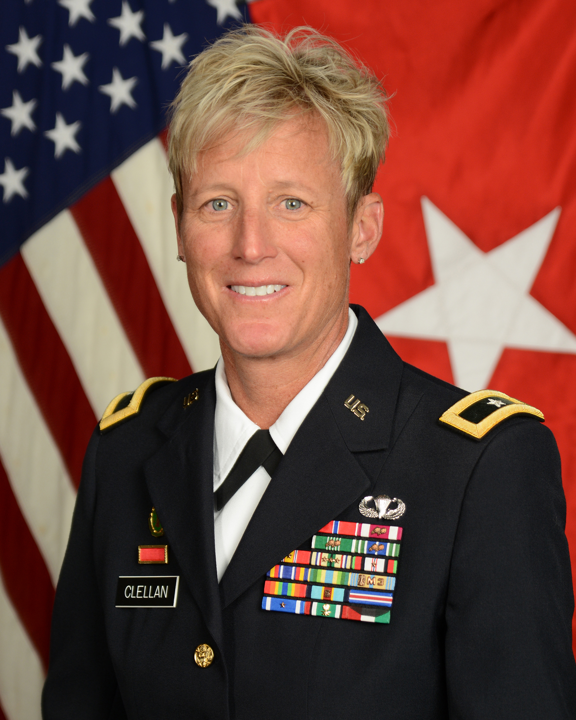Brigadier General Laura L. Clellan
The Adjutant General of Colorado
Colorado Department of Military and Veterans Affairs

The Adjutant General Priorities
- Safety and health of our people
- Strength
- Readiness
- Customer Focus

Brigadier General Laura L. Clellan
The 44th Adjutant General of Colorado
Brigadier General Laura Clellan is The 44th Adjutant General of Colorado. Appointed by the Governor of Colorado, General Clellan serves as the Executive Director of the Department of Military and Veterans Affairs and is a member of the Governor’s Cabinet. The DMVA consists of the Colorado National Guard, the Division of Veterans Affairs, and the Colorado Wing of the Civil Air Patrol totaling more than 6,700 Soldiers, Airmen, State employees, and Volunteers. As Adjutant General, General Clellan is responsible for the operation and management of readiness, fiscal, personnel, equipment, and real property resources of the Department, and ensures the training readiness of all personnel to accomplish both state and federal missions. Additionally, General Clellan is responsible for supporting the State Partnerships with Slovenia and Jordan and a strategic partnership with Israel’s Home Front Command.
EDUCATION
United States Army War College - MSS - Strategic Studies
University of Rio Grande/Rio Grande Community College - BS - Biology
University of Phoenix - MA – Education
United States Judge Advocate School, Reserve Component - General Officer Legal Orientation Course (RC-GOLO)
Army Strategic Education Program-Basic (ASEP-B)
Dual Status Commanders Course (NORTHCOM)

ASSIGNMENTS
- Aug 20-Present, The Adjutant General of Colorado, Joint Force Headquarters-Colorado
- Oct 17-Nov 19, Assistant Adjutant General, Colorado Joint Force Headquarters, Englewood, Colorado
- Sep 14-Oct 17, Commander, Land Component Command, Centennial, Colorado
- May 12-Sep 14, Commander, 168th Regional Training Institute, Colorado Army National Guard, Fort Carson, Colorado
- Jun 11-May 12, Executive Officer, 89th Troop Command, Colorado Army National Guard, Denver, Colorado
- Feb 10-Jan 11, Commander, 193rd Military Police Battalion, Afghanistan
- May 07-Jun 11, Commander, 193rd Military Police Battalion (I/R), Colorado Army National Guard, Denver, Colorado
- Jul 06-May 07, S1, Special Operations Detachment, Korea, Colorado Army National Guard, Denver, Colorado
- Jul 06-May 07, J1, TSOD-SOKOR, Aurora, Colorado
- Jul 03-Jul 06, Assistant Professor of Military Science, University of Colorado, Colorado Army National Guard, Boulder, Colorado
- Jan 02-Jun 03, S1, 89th Troop Command, Colorado Army National Guard, Denver, Colorado
- Jan 01-Jan 02, Commander, State Area Headquarters, Colorado Army National Guard, Centennial, Colorado
- Jul 00-Jan 01, Assistant S3, 1/89th Troop Command, Colorado Army National Guard, Denver, Colorado Sep 99-Mar 00, Commander, 220th Military Police Company, Hungary
- Nov 98-Jul 00, Commander, 220th Military Police Company, Colorado Army National Guard, Denver, Colorado
- Jan 97-Oct 98, Observer Controller, 91st Training Division, United States Army Reserve, Denver, Colorado
- Jan 92-Jul 92, Executive Officer, 978th Military Police Company, Panama
- Oct 90-May 91, Platoon Leader, 193rd Military Police Company, Saudi Arabia
- Dec 89-Apr 90, Platoon Leader, 978th Military Police Company, Honduras
- Nov 89-Sep 92, Platoon Leader, 978th Military Police Company, Law Enforcement Battalion, Fort Bliss, Texas
- Jul 89-Nov 89, Student, Military Police Basic Course, Fort McClellan, Alabama

SUMMARY OF JOINT ASSIGNMENTS
- Jul 06-May 07, J1, TSOD-SOKOR, Aurora, Colorado

DECORATIONS AND BADGES
Bronze Star Medal Meritorious Service Medal (with 2 Bronze Oak Leaf Clusters)
Army Commendation Medal (with 2 Bronze Oak Leaf Clusters)
Army Achievement Medal (with 2 Bronze Oak Leaf Clusters)
Army Meritorious Unit Commendation National Defense Service Medal (with Bronze Service Star)
Southwest Asia Service Medal (with 3 Bronze Service Stars)
Afghanistan Campaign Medal (with Campaign Star)
Global War on Terrorism Service Medal Armed Forces Service Medal Armed Forces Reserve Medal (with Bronze Hourglass, M Device, and Numeral 3)
Army Service Ribbon Army Overseas Service Ribbon (with Numeral 5)
Army Reserve Components Overseas Training Ribbon NATO Medal with Bronze Service Star
Bosnia and ISAF Kuwait Liberation Medal
Saudi Arabia Kuwait Liberation Medal-Government of Kuwait
Colorado Achievement Ribbon
Colorado TAG Outstanding Unit Citation (with Bronze Service Star)
Colorado Active Service Medal (with Bronze Service Star)
Colorado Emergency Service Ribbon
Colorado Foreign Deployment Service Ribbon (with Bronze Service Star)
Colorado State Mobilization Support Ribbon Parachutist Badge Drivers Badge

PROFESSIONAL MEMBERSHIPS AND ACHIEVEMENTS
National Guard Association of Colorado
Military Officers Association of Officers Association
United States Army Military Police Regimental Association

PROMOTIONS DATE OF APPOINTMENT
Second Lieutenant 24 May 89
First Lieutenant 9 Jul 91
Captain 28 Jul 95
Major 2 Mar 01
Lieutenant Colonel 1 May 07
Colonel 3 Dec 12
Brigadier General 27 Oct 15

(current as of Aug 2020)

